TACTICAL RADIO GEAR, LLC
RUGGED, RELIABLE & READY
A whole new generation of Ham Radio products
DTC - 4
Digital Turns Counter
Installation Instructions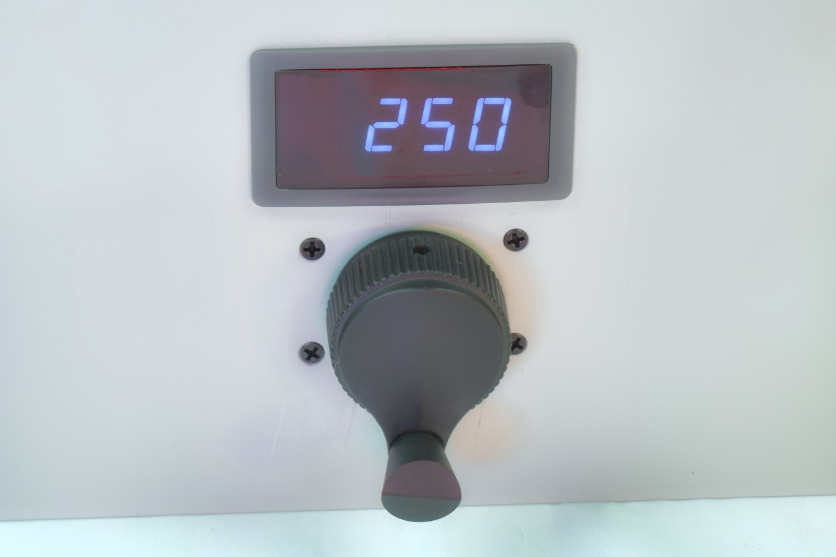
MADE IN THE USA

Table of Contents

Quick Start
- Read First
  - Product Description
  - Unpacking and inspection
  - What comes with the DTC-4
  - Limits
- Overview
- Introduction
- Digital Turns Counter
  - Significant Features
  - Specifications
  - Power Requirements
  - Mechanical
  - Mounting
- Installation & Operation
- Options & Accessories
  - Basic Counter no knob
  - Large spinner knob
  - Medium crank knob
  - Medium finger knob
- Contact information
- Warranty

Please read the Installation Instructions carefully before installing the DTC-3.5 kit.

Product Description
The DTC-4 is a general purpose, 4-digit LED display, position indicator, manufactured by Tactical Radio Gear.
The DTC-4 was designed as a low-cost, precision positioning turns counter kit. Ideal for monitoring the rotation/position of RF tuning components, such as capacitors, Inductors, potentiometers; virtually any mechanism requiring a precision positioning indicator/display. The main tuning shaft, is supported by dual bushing-bearings, to provide maintenance-free, smooth operation.

UNPACKING & INSPECTION
When unpacking the DTC-4 confirm the presence of the following items:
- DTC-4
  - (1) 12” Power cable with 2-pin Connector. (Installed)
  - (4) X ¼” x 2-1/4” Hex 4-40 aluminum spacers.
  - (4) X 4-40 s/s Socket cap-screws w/loc-washers for mounting (4) x spacers.
  - (4) X 4-40 Flat head BO machine screws for mounting (4) spacers to front panel.
  - (2) Panel bushings w/hardware for shaft.
  - (2) Brass gears
  - (1) ¼” x 1.5” stainless D-shaft
  - (1) ¼” x 2” stainless D-shaft
  - (1) Shaft coupler adapter.
  - (1) ¼” female shaft coupler.
  - (1) Snap-in LED Digital display module.
  - (1) Turns counter mechanism assembled.
  - (2) tie-wraps
  - Mounting template drawing and dimensions.
- Instruction Manual (on-line pdf down-load)
If any of these items are missing, or appear to be damaged, save the carton and packing material. Notify the dealer/distributor if purchased through one, or Tactical Radio Gear, if purchased directly.
Introduction
These instructions are intended to specifically address the DTC-4 and deals primarily with the installation, and applications. A comprehensive section in this information, covers the options, and accessories available to the customer. Every component is precision engineered to achieve maximum performance and durability. The DTC-4 kit, is ideal for fine-tuning capacitors, roller inductors; and is the perfect positioning device, for both the Amateur, Commercial amplifiers/tuners; to include RF generators, and sub-systems, requiring precision positioning of its components.

Significant Features

The DTC-4, is ideal for rotating, and fine-tuning capacitors, roller inductors; and is the perfect positioning device, for both Amateur, commercial amplifiers, and tuners; to include sub-systems requiring precision positioning of its components.

The DTC-4 is an affordable, precision turns counter, suitable for many types of applications, to accurately position nearly any mechanical device.

- The DTC-4, is a precision, commercial grade, digital turns counter. Made in the USA, using the highest quality components, and materials. Accurate, highly stable display of the components position.

- 4 digit high efficiency (Optional) Red/Green/Blue LED display.
- The display retains the number automatically when powered off.
- 0.55 inch LED Character height (See display image in picture gallery)
- Digital counting range: 0-9999 up/down counter.
- Positioning: 24 counts per 360 degrees/revolution w/Shaft-Encoder.
- Customers can rest/clear the display by pushing the knob.
- All necessary mounting hardware; and wiring is provided; to include a 1:1 cut-out template, for mounting the assembly to a panel.
- Guaranteed satisfaction. Manufactured in the USA to commercial standards; with professional quality.
- Return Shipping paid by Tactical Radio Gear, Corp. Full exchange policy for any reason you are not dissatisfied with your purchase. 100% Refund, and Return Policy.
- The DTC-4 is designed, using dual brass-bushings & gears, to support the main tuning shaft.
- A universal 1/4" aluminum shaft coupler, at the rear, provides for precise, convenient linking to component(s) with standard 1/4" shaft(s).
- An insulated Delrin coupler is available as an optional accessory.
- Optional 6:1 Vernier reduction drive.
- Three Knob options to choose from.

DTC-4

Specifications

Power requirements
- Voltage requirement: 8-24vdc.
- Nominal current requirements: 30 mA @ 12vdc
- 4 digit, High efficiency Red LED display, 0.55 inch Character height.
  - Note: current demand is a function of the number of LED segments active in the display.
- Gear ratio: 1:1
- Resolution: 24 pulse/360 degree revolution= 15 degree accuracy
- Gears: – (2) x Brass 32 pitch 24T

DTC-4
Mechanical
Dimensions:
Width: 2.50 in.
Height: 2.20 in.
Depth: 3.500in. (Measured from front panel back, less shaft coupler)
Weight: 10 oz. (Less Knob)

CAUTION
INSTALATION AND OPERATION
Before installing the DTC-4, make all electrical connections, and test for proper operation.
Warning: Select a mounting location, where the DTC-3.5 cannot come in contact with high voltage or Hot-RF components’.

The DTC-4’s circuit is RF bypassed, to prevent erroneous readings caused by local RF getting into the DTC-4 circuitry. While the DC power cable is RF by-passed, care should be taken not to run the cable on or close to Hot RF components.

The shaft coupler is made of aluminum. If a Hot RF shaft connection is contemplated; an insulated shaft coupler will need to be considered. See option (8) in accessories for an insulated shaft coupler.
STEP #1
Preparation for installation. Collect tape, scissors and a square. Measure where the template pattern is going to be laid out?

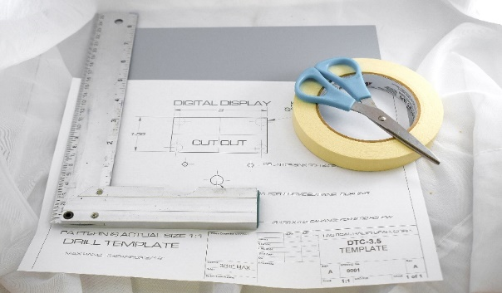
STEP #2

Cut the template pattern out of the drawing, and use a square to accurately position the template. The cut-out for the snap in digital display, does not have to use these dimensions. It can be placed at a location of the customer’s choice. Note: The 5-hole pattern placement is critical, due to the mechanical interface on the back side of the panel with the shaft and gears!

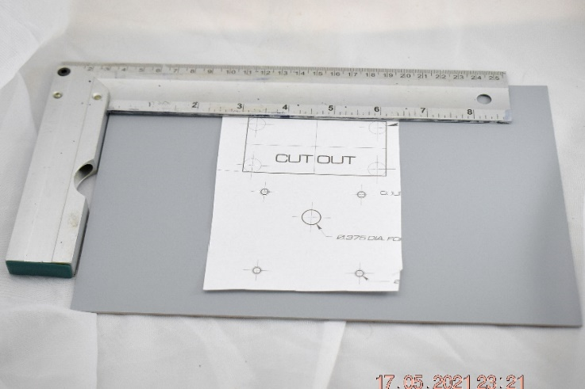

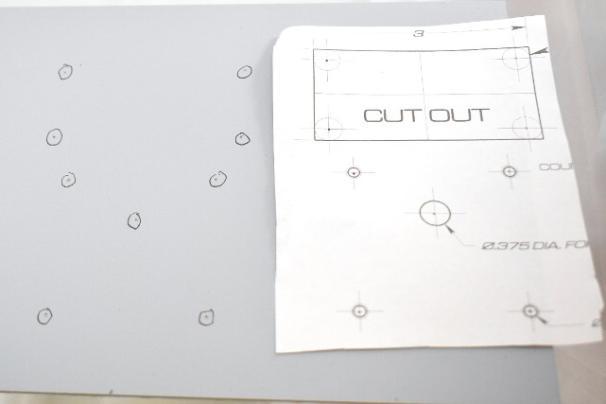
STEP #4 Check the DTC-4 kit to ensure that it is complete.
STEP #3
Check the holes with the template and move to fabricating the panel.
Tape the template in-place and use a center punch to locate the holes.

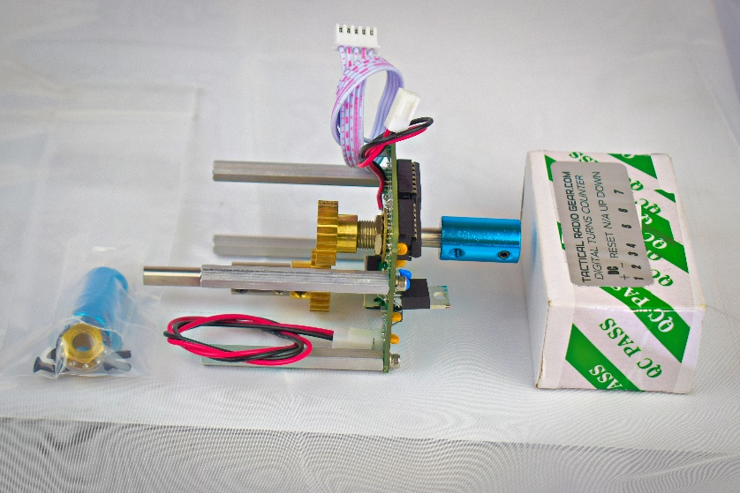

STEP #5 Connect everything to ensure that the counter is functioning properly.

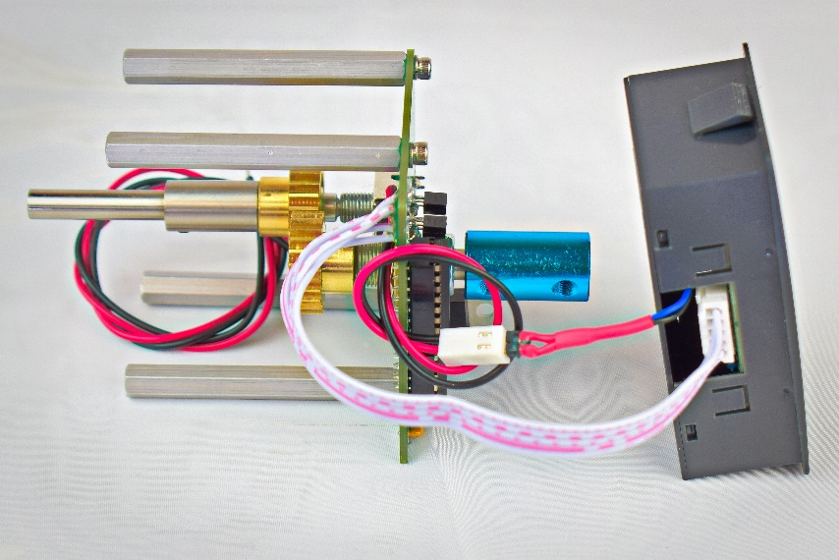

STEP #6
After the fabrication and painting of the panel, install the panel bushing and 4 x 1” x 4-40” spacers. (Panel example)

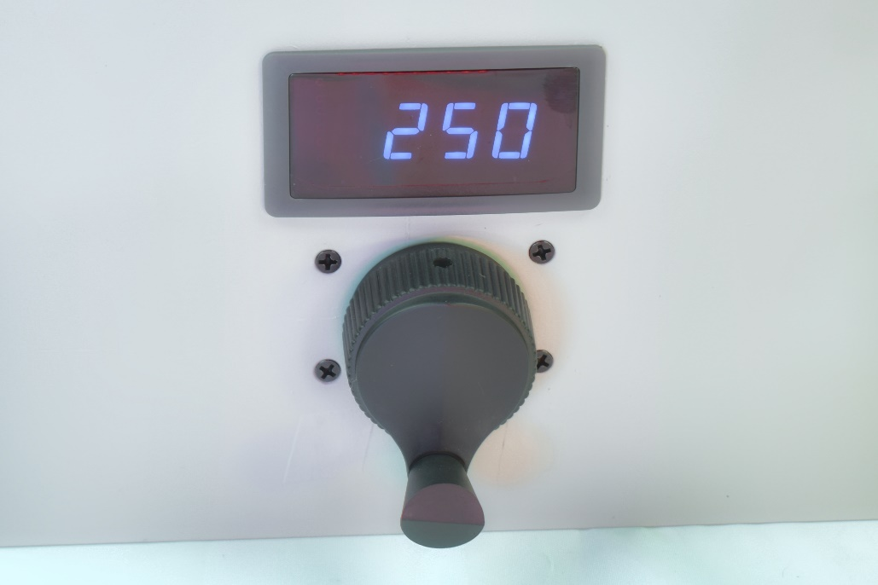
Customers’ panel.
Add a drop of light oil to the bushings after the installation is complete.

LED Snap-in Digital Display Module.

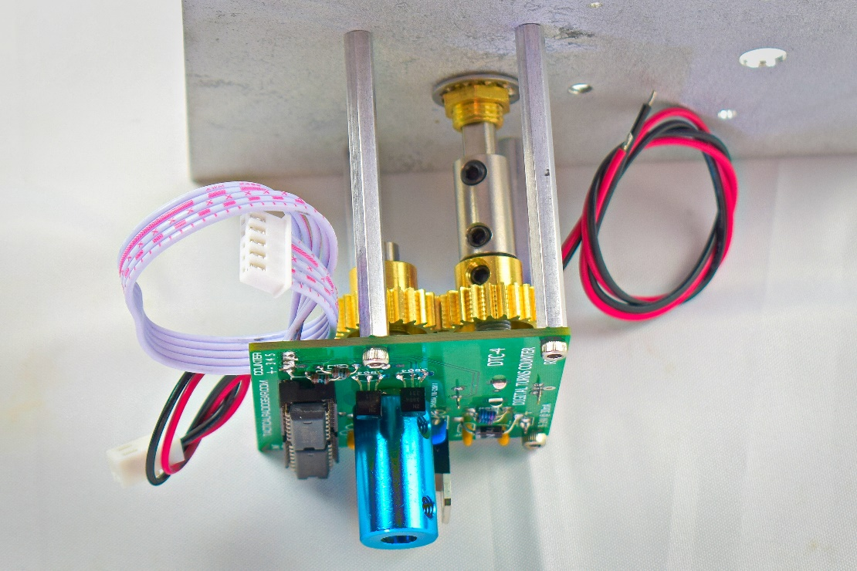

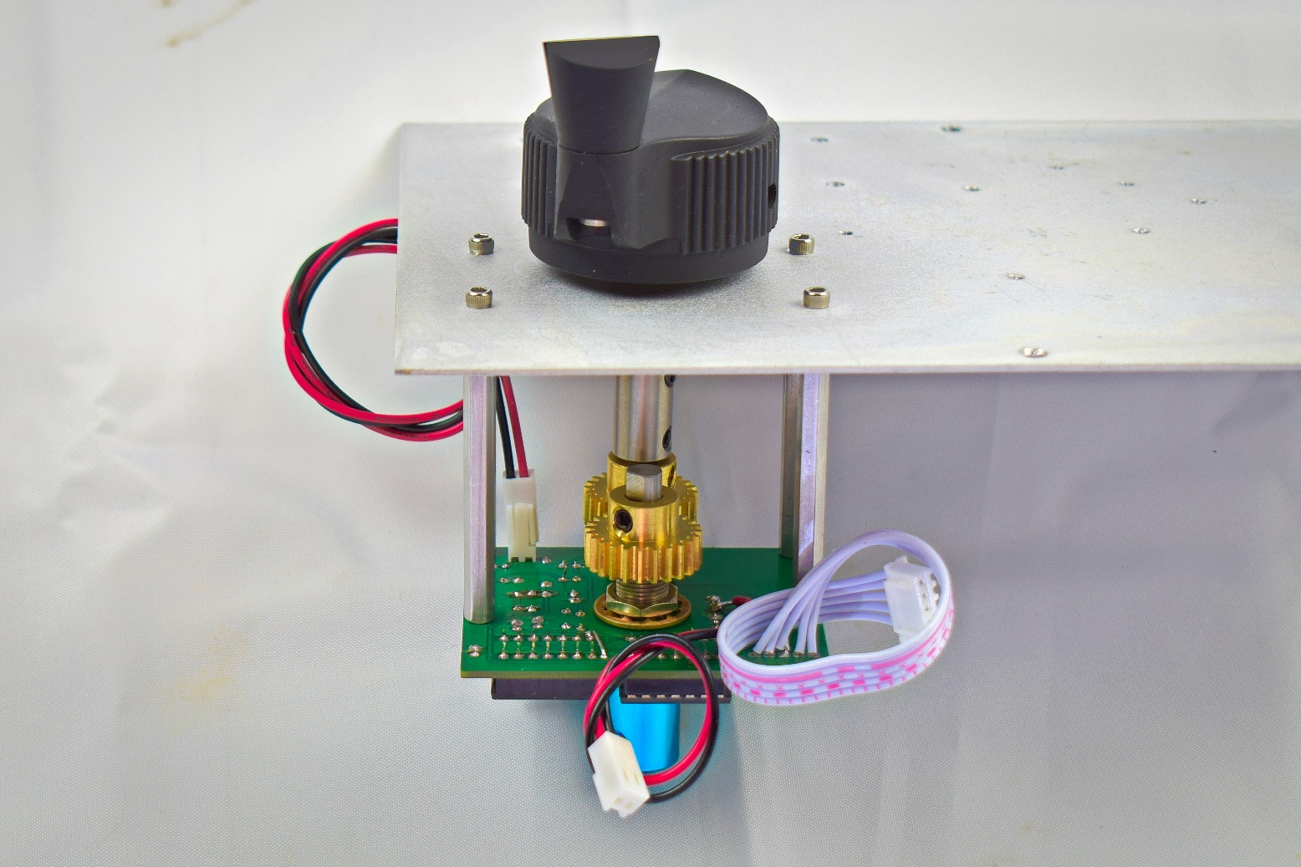
Count direction, connector. Reverse to change the UP/DOWN direction to correspond with the component to be rotated.
12” Main DC Power cable. 9-36VDC.

Shaft Coupler is adjusted to control the length of shaft at the front panel, for the best dimension, to position the knob. The coupler is positioned at the end to lock the shaft in place; in-order to prevent it from moving back and forth.

The gears need to be aligned, and properly meshed, and the shaft adjusted, and locked in place with the coupler.

Options & Accessories
The DTC-3 Digital Turns Counter system, features’ (6) different styles of knob options. Additional insulated shaft couplers, and 6:1 Vernier Drive reduction kit are available.
KNOBS:
Basic Counter less knob: DTC-3.5
(Add knob style)
(1) Large Military Style spinner knob….……………. ….. $29.00
(2) Plastic crank knob…………………….................... ….. $10.00
(3) Medium plastic finger knob……………………............ $15.00
See knob images below for style designation number.
ACCESSORIES:
(4) Vernier Drive 6:1 installation kit…………………………… $25.00
(5) Insulated (Delrin) 1.0” long x ½” OD Shaft Coupler …… $10.00
(6) Gear ratio option 1:1 option…………………………………$15.00

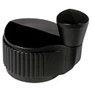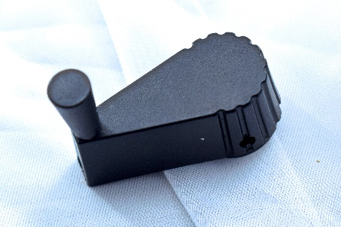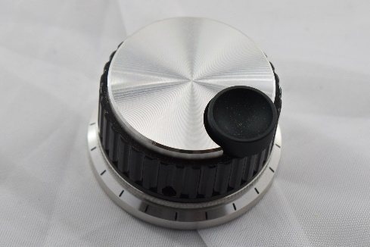
4
3
1
2
5

Contact Information
For Sales inquiries: 541-614-0973 (Leave message if no answer)
For Support: 541-270-2273
Shipping Address: 551 SE KEEL AVE. LINCOLN CITY, OREGON 97367
Website: http://www.TACTICALRADIOGEAR.COM
Email: <tactical.radio.gear@gmail.com>

Standard Equipment Warranty

SELLER’S WARRANTY IS EXCLUSIVE, AND SELLER DISCLAIMS ALL OTHER
WARRANTIES, EXPRESS OR IMPLIED, INCLUDING BUT NOT LIMITED TO THE IMPLIED WARRANTIES OF MERCHANTABILITY AND FITNESS FOR A PARTICULAR PURPOSE.
All products sold by Tactical Radio Gear LLC, are warranted against defects in material and workmanship for a period of 1 year from the date of shipment. If you believe this product has a defect in material or workmanship or has failed during normal use within the warranty period, please contact Tactical Radio Gear, in the listed contact information for assistance. If product repair or replacement is necessary, the Customer will be solely responsible for all shipping charges, freight, insurance and proper packaging to prevent breakage in transit, whether or not the product is covered by this warranty. All shipments of repaired or replaced products by Tactical Radio Gear LLC, is F.O.B. Lincoln City, Oregon 97367 USA.
This warranty does not apply to defects resulting from mishandling, operation outside of design limits, misapplication, or unauthorized modification; breaking the Warranty Seal(s) voids all stated and/or implied warranties. No other warranties are expressed or implied. Tactical Radio Gear LLC, liability shall be limited to the actual purchase price of any defective unit to which a claim is made, and shall in no event include the Customer's, lost profits or goodwill, or any other direct, indirect, special, incidental or consequential damages.

